Create a simple cloud software application for Mark Sheet Processing System using any Cloud Service Provider to demonstrate SaaS include the necessary fields such as name of the student, Reg no of the student, Subjects, Marks, Average, percentage, rank, overall performance etc.

Step1: Create a Scratch to do a Form for Student Marks Processing System.

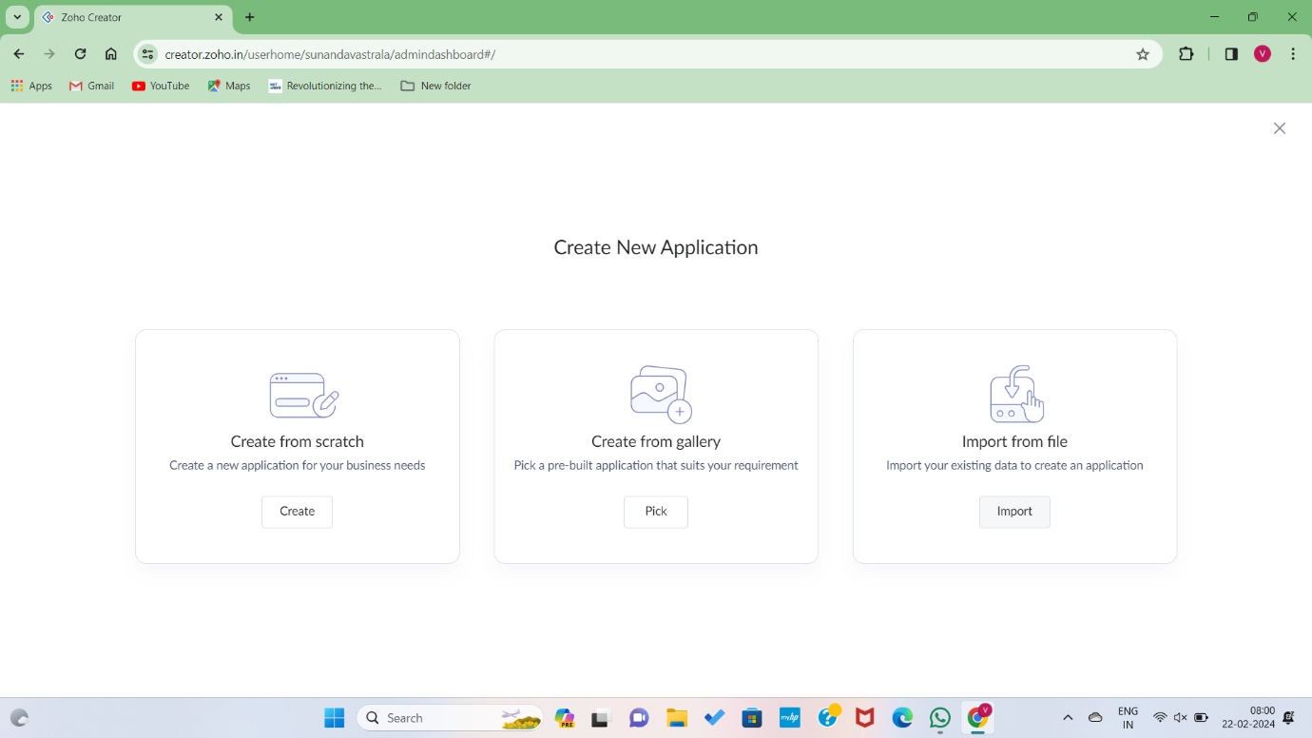

Step2: After Going to scratch go and enter application name, and build forms for student marks processing system through online.

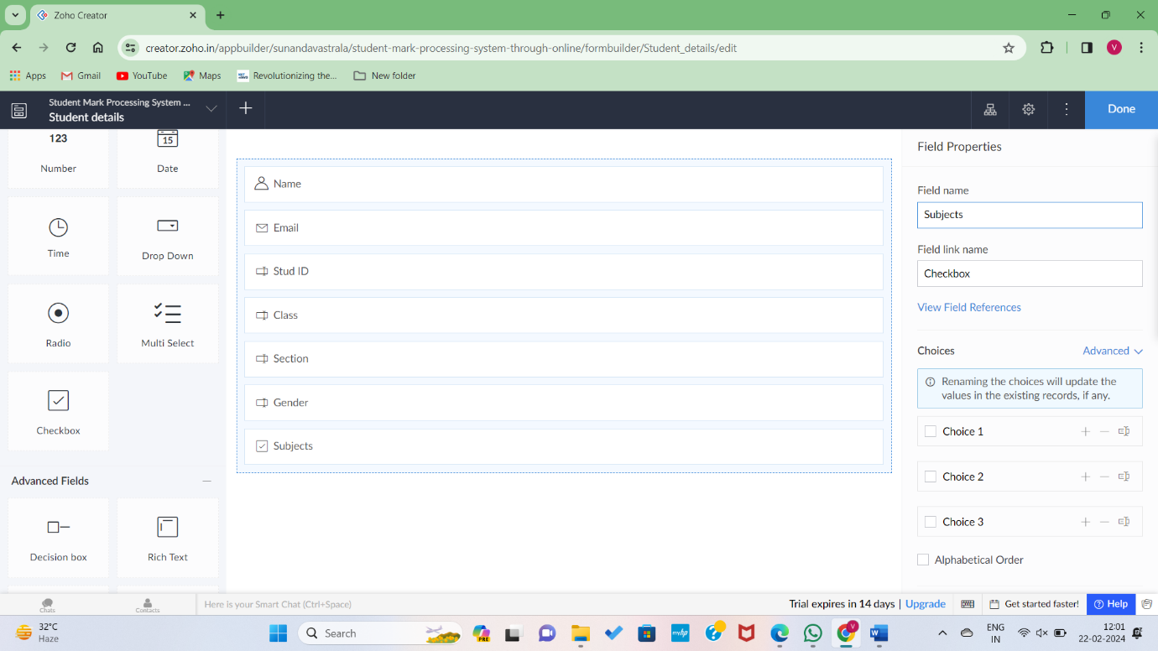

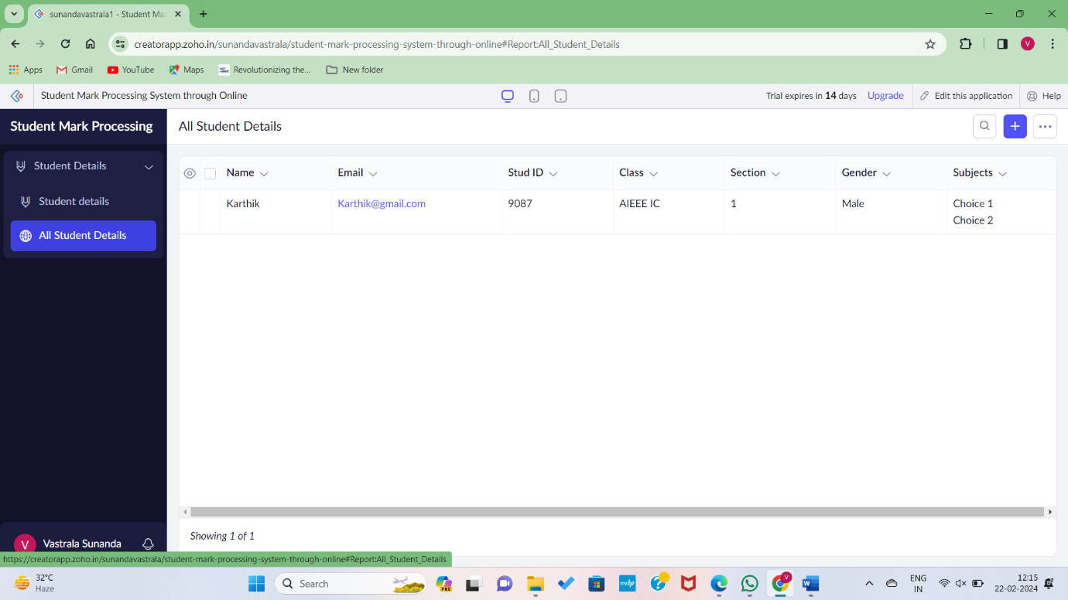

Step3: Entering the student details about marks register number, Subjects and Phone number etc..

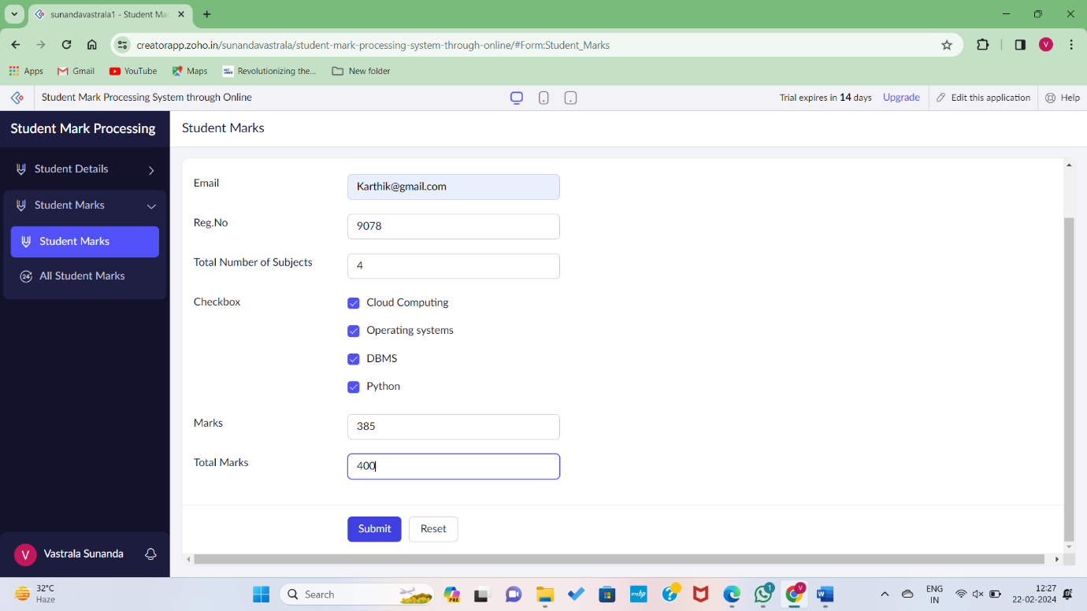

Step5: The Student Mark Processing details Successfully Added to the Data

